Q1. The Bonita Vista Golf & Country Club details the following accounts in its financial statements.

Classify each of the following accounts as an asset, liability, stockholders' equity, revenue, or expense item.

|  |  |
| --- | --- |
| **CLASSIFY EACH ACCOUNT** |  |
| Accounts payable |  |
| Accounts receivable |  |
| Equipment |  |
| Sales revenue |  |
| Service revenue |  |
| Inventory |  |
| Mortgage payable |  |
| Supplies expense |  |
| Rent expense |  |
| Salaries and wages expense |  |

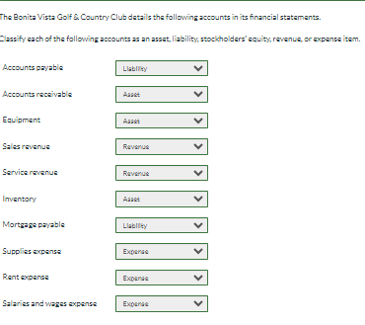

Q2

This information relates to Metlock, Inc. for the year 2022

Retained earnings, January 1, 2022 $64,320

Advertising expense $1,728

Dividends $5,760

Rent expense $9,984

Service revenue $ 55,680

Utilities expense $2,304

Salaries and wages expense $28,800

a) Prepare an income statement for the year ending December 31, 2022.

b) Prepare a retained earnings statement for the year ending December 31, 2022. (List items that increase retained earnings first.)

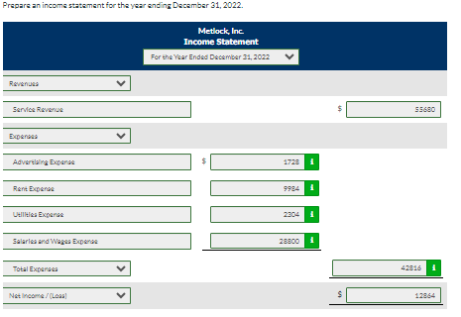

Q3

The following information is available for Sandhill Inc.  
Accounts receivable $2,352  
Cash $6,125  
Accounts payable $3,626  
Supplies $3,683  
Interest payable $572  
Unearned service revenue $833  
Salaries and wages expense $4,410  
Service revenue $40,098  
Notes payable $30,870  
Salaries and wages payable $731  
Common stock $49,686  
Depreciation expense $4653  
Inventory $2,785  
Equipment (net) $106,036  
Using the information above, prepare a balance sheet as of December 31, 2022. (Hint: Solve for the missing retained earnings amount.) (List Assets in order of liquidity.) 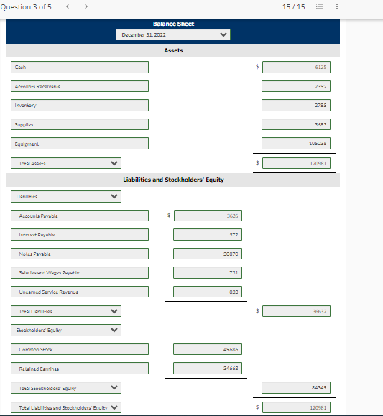Q4

Classify each of the following financial statement items taken from Ming Corporation's balance sheet.

a) Accounts payable -   
(b) Accounts receivable –

(c) Accumulated depreciation—  
(d) Buildings –

(e) Cash –

(f) Interest payable -  
(g) Goodwill

(h) Income taxes payable -   
(i) Inventory -   
(j) Stock investments (to be sold in 7 months) -   
(k) Land (in use) -   
(l) Mortgage payable –

(m) Supplies -   
(o) Prepaid rent –

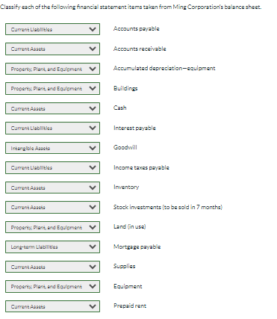

Q5

These items are taken from the financial statements of Blossom Co. at December 31, 2022.

Buildings $94,640

Accounts receivable 10,000

Prepaid insurance 2,560

Cash 9,472

Equipment 65,920

Land 48,960

Insurance expense 624

Depreciation expense 4,240

Interest expense 2,080

Common stock 48,000

Retained earnings (Jan 1, 2022) 32,000

Accumulated depreciation-buildings 36,480

Accounts payable 7,600

Notes payable 74,880

Accumulated depreciation-equipment 14,976

Interest payable 2,880

Service revenue 11,760

Prepare a classified balance sheet. Assume that $10,880 of the note payable will be paid in 2023. (List Current Assets in order of liquidity. List Property, Plant and Equipment in order of Land, Buildings and Equipment)

